10 Variables



This section will guide you to understand:

* How to create a variable

**Development Environment**

* Postman Tool
* Endpoint URL

This guide has three subsections, namely:

2.10.1 Creating a variable

2.10.2 Using the variable

2.10.3 Pushing the code to your GitHub repositories

**Step 2.10.1:** Creating a variable

* Create a Collection

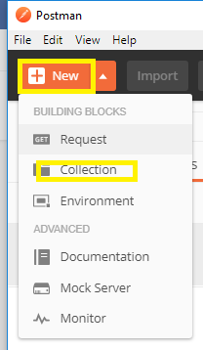

* Create two Requests

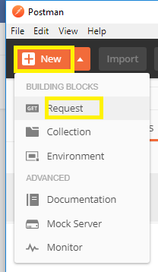

* Use these two URLs:

<https://reqres.in/api/users?page=2>

<https://reqres.in/api/users/2>

* Save both the Requests

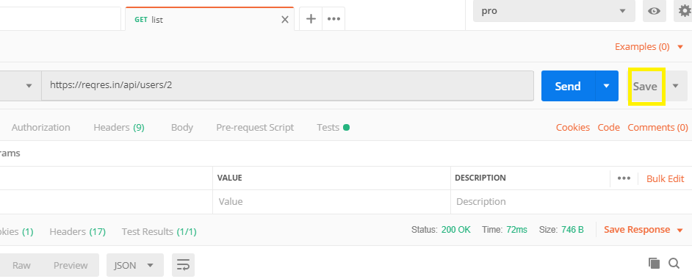

* Go to **Collection** (three-dot mark) and click on it
* Click **Edit**

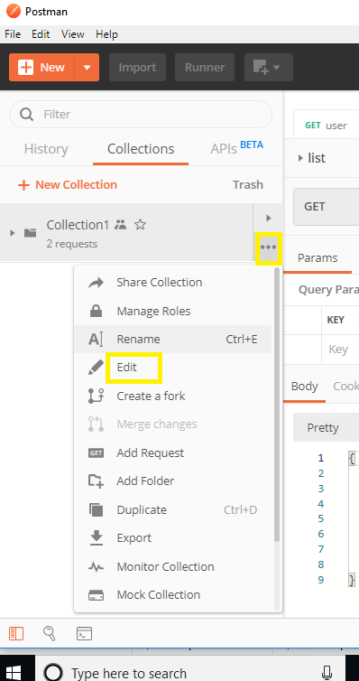

* Go to the Variable option
* Create a Variable

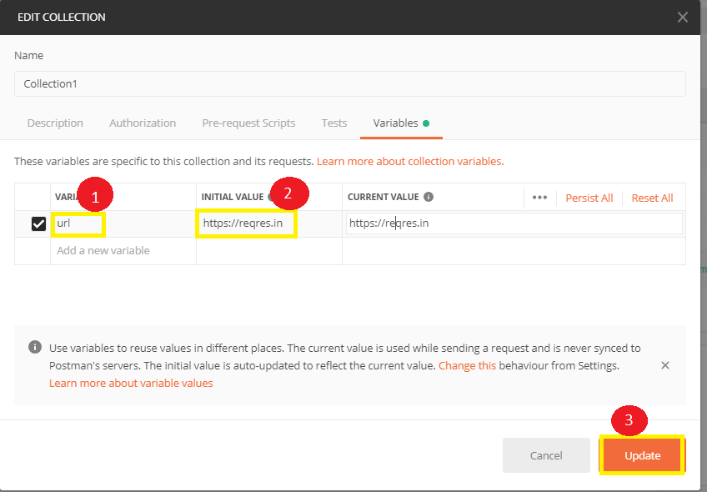

**Step 2.10.2:** Using the variable

* Use your variable and click Send

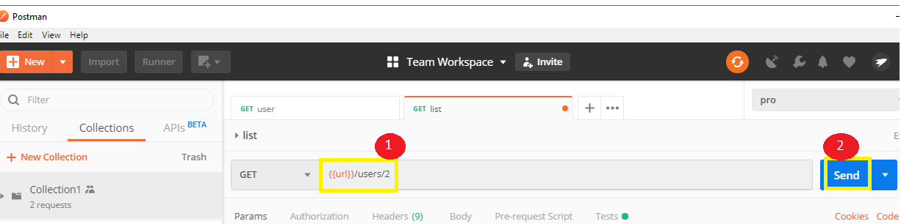

* The output will look like:

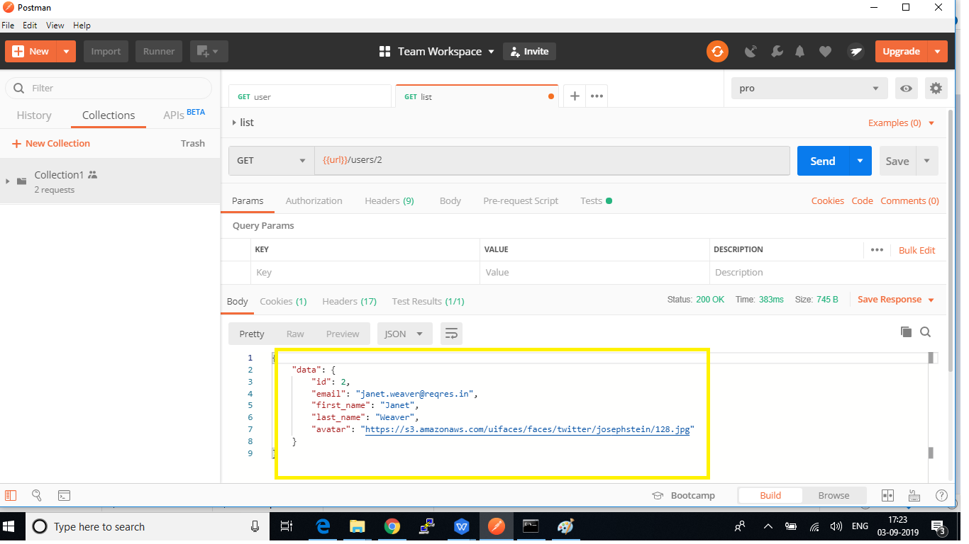

**Step 2.10.3:** Pushing the code to your GitHub repositories

Open your command prompt and navigate to the folder where you have created your files

cd <folder path>

Initialize your repository using the following command:

git init

Add all the files to your git repository using the following command:

git add . 

Commit the changes using the following command:

git commit . -m “Changes have been committed.”

Push the files to the folder you initially created using the following command:

git push -u origin master